Preliminary Project Proposal

Group Members: Xie Ziqi (MC651648), Chen Ruxin (MC652093)

Course: CISC7204-D Data Science and Data Visualization

Coursework: Assignment 01

Submission Date: 2026.9.16

1. Project Title (Region, Domain Category, Research Question)

Title: Monthly Visitor Arrivals and Hotel Room Occupancy in Macao, 2024–2025.

Region: Macao SAR.

Domain: Tourism and hospitality.

Research question: Is there a statistically significant positive association between monthly

visitor arrivals and the average hotel room occupancy rate in Macao from January 2024 to

December 2025? Do months with more arrivals tend to have higher occupancy?

2. Project Purpose (Outcomes, Skills, Knowledge)

Outcomes: Produce a reproducible comparison of two official monthly tourism indicators,

with a cleaned 24-month dataset, interpretable charts, and a conclusion that answers the

research question.

Skills: Import .xls and .xlsx files with Python/Pandas; identify month labels and units; merge

and validate records; compute descriptive statistics and Pearson correlation; create clear

figures in Matplotlib; explain findings in a report.

Knowledge: Understand Macao tourism patterns, hotel room occupancy as a percentage of

available rooms, seasonal variation in monthly series, and the difference between association

and causation.

3. Dataset Information (Dataset 1, Dataset 2)

Dataset 1 — Visitor Arrivals.

Publisher: Statistics and Census Service (DSEC), Government of the Macao SAR.

Official database:

https://www.dsec.gov.mo/timeseriesdatabase.aspx?keyindicatorid=27&lang=en-US .

Supplied file: DSEC visitor-arrivals export (.xls).

Selected period: January 2024–December 2025.

Variable: total visitor arrivals per month (persons).

Use: explanatory comparison variable.

Dataset 2 — Average Hotel Occupancy Rate.

Publisher: DSEC, Government of the Macao SAR.

Official statistics page (select “Package Tours and Hotel Occupancy Rate”):

https://www.dsec.gov.mo/statistic.aspx?lang=en-us .

Supplied file: DSEC hotel-occupancy export (.xlsx).

Selected period: January 2024–December 2025.

Variable: monthly average room occupancy rate (%).

Use: hotel outcome measure.

Both supplied DSEC exports contain longer historical series. The analysis filters them to the

same 24 complete months. The two published series are distinct datasets serving one question.

The supplied spreadsheet values match both team notebooks.

4. Project Tasks (Steps, Tools and Methods, Deliverables)

1. Verify the DSEC files, variable definitions, units, dates, and 24-month overlap; record

direct source links and download dates.

2. Read the original spreadsheets in Pandas; convert different month labels to dates; filter

January 2024–December 2025; join one-to-one by month; check missing, duplicate, and

out-of-range values.

3. Summarize monthly ranges and year patterns. Compute the Pearson coefficient and its

conventional two-sided p-value; compare the relationship within each year and between

consecutive monthly changes as descriptive checks.

4. Draw and interpret the planned figures. Deliver the proposal, cleaned CSV, executable

Jupyter Notebook, visualizations, written report, and presentation. Keep source files and code

together for reproduction.

5. Proposed Visualization (Plan and Justification)

Time-series figure: Two aligned line charts share the month axis while showing arrivals in

millions and room occupancy in percent on separate scales. This displays peaks, dips, and

year-to-year changes without mixing unlike units.

Relationship figure: A scatterplot places arrivals on the horizontal axis and occupancy on the

vertical axis, colors points by year, and shows an overall fitted line. This makes the direction

and spread of the association visible.

The figure captions will identify DSEC as the source, state the selected period and units, and

note that the occupancy axis is truncated for visibility. A two-variable correlation heatmap is

unnecessary because it repeats the scatterplot’s coefficient.

6. Criteria for Success

Success requires two accessible official series with aligned monthly definitions; a complete,

validated 24-row merged dataset; runnable Python code; and charts with clear titles, dates,

axis units, legends, and source captions. The report must state the strength and direction of the

association, explain the p-value correctly, and distinguish correlation from causation. The

team will use the assignment checklist or rubric to verify each required deliverable.

7. Project Collaboration (Division of Work, Team Roles, Ground Rules)

Chen Ruxin: Data collection, report writing, and document formatting.

Xie Ziqi: Topic exploration and data analysis.

Both members: Finalized the research question, created and reviewed the visualizations,

checked the interpretation of results, and approved the final submission.

Roles may be combined according to team size. Each member will review another member’s

output, keep source citations with the figures, use one shared version of the cleaned

dataset,and agree on changes to the research question or time period before editing the report.

All members will check the final notebook and assignment checklist.

8. Results

After the two DSEC series were filtered and merged by month, the final dataset contained 24

complete observations from January 2024 to December 2025, with no missing months.

Monthly visitor arrivals ranged from 2,528,011 in September 2024 to 4,219,034 in August

2025. The average hotel room occupancy rate ranged from 82.8% in June 2024 to 93.1% in

August 2025. Therefore, both variables reached their highest observed value in August 2025.
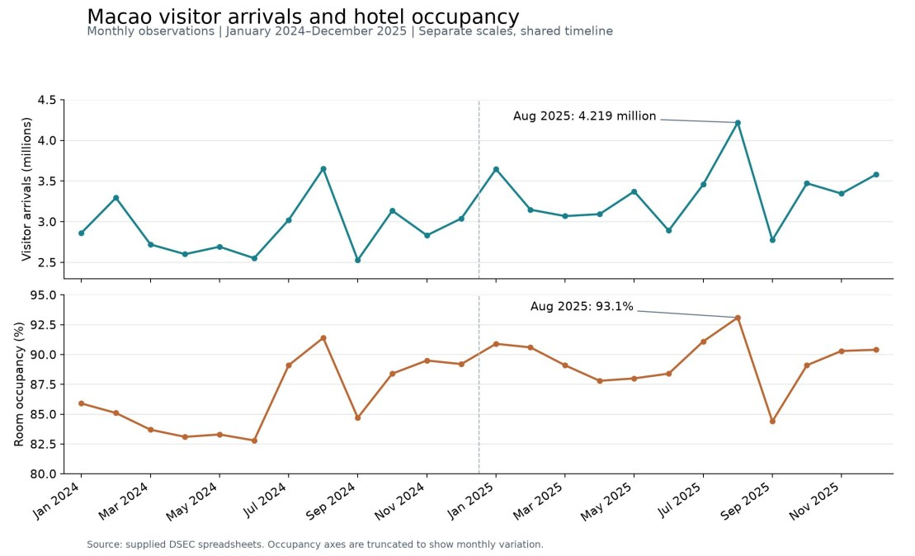

Pearson correlation analysis produced r = 0.823 (n = 24, p < 0.001), indicating a strong

positive association between monthly visitor arrivals and hotel room occupancy. The

corresponding in-sample R² was 0.678. In addition, visitor arrivals and occupancy moved in

the same direction in 17 of the 23 month-to-month transitions. The trend charts and scatterplot

therefore show that months with more visitor arrivals generally had higher hotel occupancy,

although the two indicators did not move together in every month.

Figure 1. Monthly Visitor Arrivals and Hotel Room Occupancy Rate in Macao, January

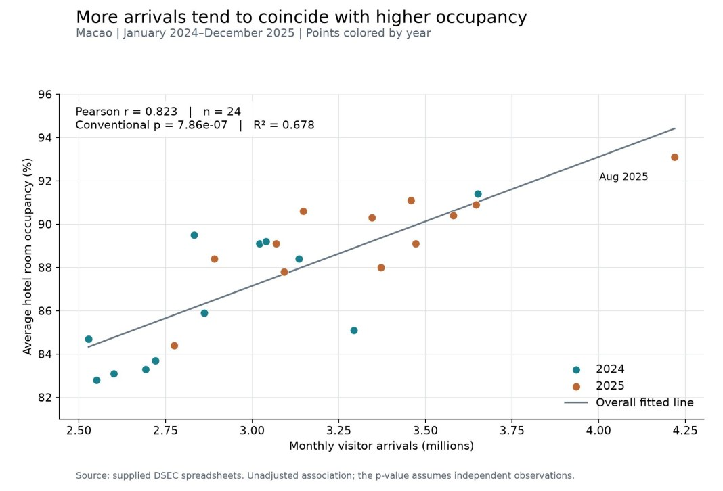
2024–December 2025

Figure 2. Relationship Between Monthly Visitor Arrivals and Hotel Room Occupancy Rate in

Macao

9. Conclusion

The findings support the proposed hypothesis: during 2024–2025, higher monthly visitor

arrivals in Macao were associated with higher average hotel room occupancy. The

relationship was statistically significant under the conventional Pearson test and was visually

consistent with the upward pattern in the scatterplot. However, this result describes

correlation rather than causation. Consecutive monthly observations may be related, and the

analysis does not control for seasonality, hotel room supply, special events, or the proportion

of same-day visitors. The project will therefore conclude that visitor arrivals are a useful

indicator of hotel occupancy patterns while acknowledging that other factors also influence

occupancy.

